Submit online at dealerapp@scubastik.com, fax, or print out and mail to the address below.

SCUBA STIK, LLC. – DEALER APPLICATION

Mailing Address Phone and Fax Number
N4873 Morken Rd. dealerapp@scubastik.com PH:1-715-284-9733
Melrose, WI 54642 www.scubastik.com Fax: 1-715-284-3024

PLEASE READ CAREFULLY! The undersigned discloses the following information for the purpose of obtaining a dealership account. Scuba Stik, LLC. reserves the right to terminate a dealership or limit the amount of purchase for repeated NSF checks, refusal of shipments or falsification of application data.

Company Name:______________________________________ Contact Name:_______________________________

Billing Address:_______________________________________________________________________________________
Street Address City State/Province Zip/Postal Code

Shipping Address:_____________________________________________________________________________________
Street Address City State/Province Zip/Postal Code

____________________________________________________________________________________________________
Telephone Number Fax Number (Include city / country codes for int’l. #) Country

____________________________________________________________________________________________________
Federal Tax ID # (USA ONLY) State Reseller # (USA ONLY)

____________________________________________________________________________________________________
E-Mail Address Website

PLEASE SELECT: ACCOUNT TYPE REQUESTED: Card Type:__________________________
__New Account __Credit Card Card #: _____________________________
__No Application on File __US$ Check / Wire Transfer
__New Ownership __COD (USA only) Exp. Date: _________ Security Code:_____

ORGANIZATION TYPE: Signature: ___________________________
__Sole Proprietor
__Partnership Print Name: _________________________
__Corporation (See Credit Card Authorization Form)

Name and Address of Owner(s):_______________________________ S.S. #_______________________________
_________________________________________________________ Drivers License #_____________________

Phone Number(s):_________________________________________________________________________________________________
(Home) (Cell) (Work)



BUSINESS TYPE: (Please check all applicable information)

__Retail Dive Business __Charter/Live-aboard/Resort

Shop Hours____________________________________ Equipment Lines Stocked/Rented_______________________

Equipment Lines Carried_________________________ __________________________________________________
_____________________________________________

__Dive Equipment Manufacturer __Government / Military / Public Service

__Industrial / Service Supplier __Educational / Research Facility

__Specialty Retailer __Commercial Dive Company

Product Types:_________________________________ Main Activity_______________________________________
_____________________________________________ __________________________________________________

Tell us about your business. Briefly describe your customer base, association memberships, other items besides scuba, etc.:
________________________________________________________________________________________________________________________________________________________________________________________________________
____________________________________________________________________________________________________

DIVE INDUSTRY REFRENCES (MANUFACTURERS AND SUPPLIERS):
Please complete all references. Your application will not be processed if incomplete. If there are no current references, please mark N/A.

1. Firm Name_______________________________ Acct. #______________ Contact Name__________________________
Address______________________________________________________________________________________________
Telephone____________________________ Fax___________________________ Email____________________________
Terms_______________________________________________________________________________________________

2. Firm Name_______________________________ Acct. #______________ Contact Name__________________________
Address______________________________________________________________________________________________
Telephone____________________________ Fax___________________________ Email____________________________
Terms_______________________________________________________________________________________________

3. Firm Name_______________________________ Acct. #______________ Contact Name__________________________
Address______________________________________________________________________________________________
Telephone____________________________ Fax___________________________ Email____________________________
Terms_______________________________________________________________________________________________

STATEMENT OF FACTS
I hereby state that all of the information I have provided above is true and correct to the best of my knowledge, and I authorize Scuba Stik, LLC. To check the references that I have provided.

SIGNATURE______________________________ DATE________________ PRINT NAME________________________

PERSONAL GUARANTEE
In the event that this account is delinquent and satisfactory arrangements have not been made for payment, all legal, attorney fees, and collection costs will be assumed by debtor. By applying for credit, being accepted, and signing this application, I agree to the above terms and conditions. I also assume personal responsibility for payment for said corporation’s account and/or the above named business’ account. It is understood that credit will not be extended to said corporation without this assumption of liability, this guarantee and every part of hereof shall extend to and be obligatory to my heirs, executors, administrators and assigns and shall insure to the benefit of Scuba Stik, LLC., their successors and assigns.

DATE_______________ PRINT NAME___________________________________________________________

SIGNATURE____________________________________________________________

If any of the above information is found to be untrue, Scuba Stik, LLC. may at their option discontinue selling any products to the above named store.

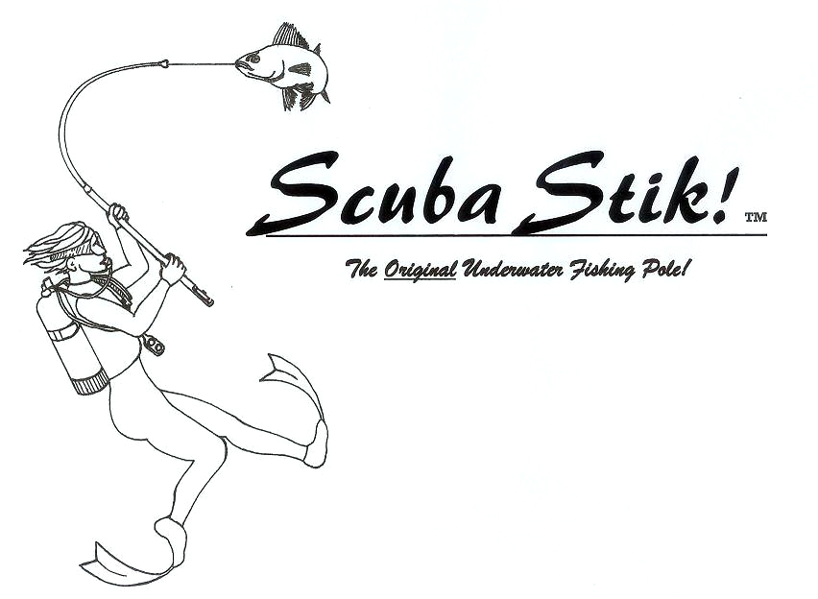

Scuba Stik, LLC. Credit Card Authorization Form

This form is used to authorize Scuba Stik, LLC. to establish automatic payment of your invoices via credit card. You will still receive invoices for your purchases if you choose this option. Please fill out this form and return it to us by mail or fax.

Mail to: Fax to: 715-284-3024
Scuba Stik, LLC.
N4873 Morken Rd.
Melrose, WI 54642

Store Name: _________________________________________

Phone Number: ______________________________________

Credit Card Information:

Type: __ VISA __ MASTERCARD __ AMERICAN EXPRESS __ DISCOVER

Account Number: ________________________________ Exp. Date: ___________

Security Code: __________ (AMEX: 4 digits printed on front side above account number)
(VISA, MC, DISC: last 3 digits on signature panel of card)

Name (as it appears on the card): __________________________________________

Billing Address (where you receive your credit card statements):

Street: ______________________________________________

City: ___________________________ State: _____ Zip Code: __________

Shipping Address:

Street: ______________________________________________

City: ___________________________ State: _____ Zip Code: __________

Authorization: I authorize Scuba Stik, LLC. to charge my card for orders/invoices placed by me or my staff, until I notify Scuba Stik, LLC. in writing. I agree to pay the above credit card charges in accordance with the Card Issuer Agreement. I understand that Scuba Stick will apply a charge back fee of $100.00 to my account, if I initialize a charge back with my credit card issuer to reverse payment without the permission of Scuba Stik, LLC. for any charges authorized on this form, and I agree to pay this fee if it occurs.

Cardholder Signature: ______________________________________________ Date: ______________

